Hula Lessons & Lei Making
Hula lessons & Lei Making are great way for you and your group to learn a little bit about our Hawaiian culture and also to have great fun through our learning our traditions.

Hula Lesson (1 hour)

Hula is a great way for you and your dearest family & friends to bond, to learn a little bit about our Hawaiian culture and also to have great fun through our traditional dance.
Hula Lessons are held in a quite area of Kapiolani Park with Diamond Head in the background. Or we can come to you! Hula is inspired by nature so it is wonderful to be outside when possible.

Your hula lesson will include the following:

Fresh Hawaiian flower for your hair (women) for you all of you to take home
- Ti leaf adornment for men

A Hawaiian women’s paʻu skirt/pareau for you to borrow for your lesson and/or picture taking. (see pics below)

An understanding of the history of hula and of the hula song and Hawaiian "kaona" (hidden meaning in the lyrics/poetry)

Approx. 3 basic hula steps

You will learn at least 3 Hawaiian words.

You will learn 1 Hawaiian Hula dance to take home with you.
- Unlimited pictures & videos with your cameras for fun memories to take home with you!

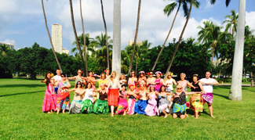

Fee:
Flat fee + pp fee based on group size

Lei Making (45 minutes)

Learn the Hawaiian art of lei making. Hula Hula will provide an instructor, bright and fragrant flowers, raffia, ti leaves, lei needles, and all you need to create a beautiful Hawaiian lei. We teach simple techniques, to create beautiful lei. Lei making is a joyful way to experience Hawaii’s traditions and is a great cultural group activity. Experience this priceless piece of history and tradition while here in the islands. Lei making classes are made “family style.” We all sit together and all of the flowers are placed in the center of the circle and we all sit and talk and as we make leis together!
At the end of the lei making lesson each person will have 1 beautiful lei to wear & take with you!

Lei making
$200 + pp fee based on group size

Hula Lesson & Lei Making (1.5 hours)

Hula Lesson
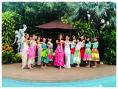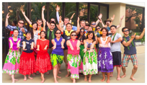
+
Lei Making
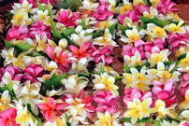

Fee:
$300 + pp fee based on group size

Deposits & Payments

We require a 50% non-refundable deposit to confirm your lesson(s) date.
The remaining balance is due not later than 2 weeks prior to your event date.

Remaining balance is due 2 weeks prior to your Hula Hula Lesson/Lei Making date.

Contact us
Hope this information helps! If you have any Qs or would like to book, please let me as much of the following information soon:

Date:
Start Time:
Location & Address:
Hula Lesson # of women, men, girls (ages) & boys (ages)
Lei making # of women, men, girls (ages) & boys (ages)
Also we’d love to know a little bit about you and your party! A few sentences.

Aloha!
Malia

Malia Haumschild, MBA
Owner, Hula Hula LLC
HulaHulaHawaii.com
808-264-1358
Joyful, Authentic, Hawaiian Entertainment

