Hawaiian Entertainment
Wow your guests with authentic Hawaiian music and a Hula! All Hula dancers perform with both Hawaiian Hula instruments (‘uli’uli, pu’ili & ipu) as well as dance with their hands & the swaying of their hips. Musicians sing vocals as well as play the ukulele, guitar or bass. All packages include an audience participation segment- We will invite your chosen guest(s) of honor, or all of your guests, to learn how to hula and get up and perform. You will be sure to create a memorable experience that no one will forget!

Plumeria Package (30 mins)

- 1 Hula Dancer
- 1 Hawaiian Musician

Ilima Package (30 mins)

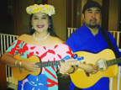
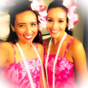
- 2 Hula Dancers
- 2 Hawaiian Musicians

Lokelani Package (30 min performance)

- 3 Hula Dancers
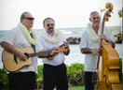
- 3 Hawaiian Musicians

*Large Hula/Polynesian shows are available! Please inquire for a quote.

Hawaiian Musician(s) ~

Recommended for ceremony, cocktail & dinner music. Our musicians play a mix of Hawaiian music &/or contemporary favorites.

Hawaiian Musician(s) ~
- Hawaiian Music Soloist (ukulele or guitar player with vocals)
1st hour-
Each additional hour-

- Hawaiian Music Duo (including ukulele player & guitar player with vocals)
1st hour-
Each additional hour-

- Hawaiian Music Trio (including ukulele player, guitar player & bass with vocals)
1 Hour-
Each additional hour-

Professional Hula Dancer(s)~

Recommended for ceremony, cocktail & during dinner hours. Hula dancers add the visual to the auditory enjoyment of the sounds of Hawaii! Hula is weaved into your event to create a uniquely Hawaiian ambiance.

Hula Dancers ~
- Hula Soloist (with traditional hula hands as well as 3 hula implements)
1st Hour-
Each additional hour-

- Hula Duo (with traditional hula hands as well as 3 hula implements)
1st Hour-
Each additional hour-

- Hula Trio (with traditional hula hands as well as 3 hula implements)
2 Wahine (female) hula dancers & 1 Kane (male) hula dancer
1st Hour-
Each additional hour-

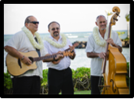

Tahitian Entertainment
Experience the excitement of Tahitian dance! Musicians play thrilling toʻere (traditional Tahitian drums). Dancers movements are characterized by circular & sharp hip movements. Additionally, all Tahitian shows include an audience participation segment! Great fun for all!

Tiare Package
1 Female Dancer
1 Musician
15-20 minute performance with audience participation

Manava Package
1 Female Dancer
1 Male Dancer
2 Musicians
20-30 minute performance with audience participation

Hinano Package
2 Female Tahitian Dancers
2 Male Tahitian Dancers
3 Musicians
30-45 minute performance with audience participation

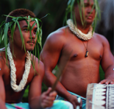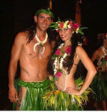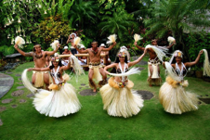

Samoan Fire Knife

Experience the excitement of Modern Fire Knife dance! Fire Knife is a traditional Samoan cultural implement that is used in ceremonial dances. It was originally composed of a machete wrapped in towels on both ends with a portion of the blade exposed in the middle. Tribal performers of fire knife dancing (or Siva Afi as it is called in Samoa) dance while twirling the knife and doing other acrobatic stunts. The towels are set afire during the dances thus explaining the name. Enjoy the thrill of this exciting dance.

Samoan Fire Knife Finale- Approx. 10 minutes
- Samoan Fire Knife Dancer + 2 Samoan Drummers

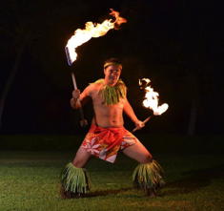

Hawaiian Lei Greeting

Make your event extra special, right from the start. Welcome your guests of honor with a hand-crafted fragrant and colorful Hawaiian lei. Guests will be greeted with a lei, a warm smile and the spirit of Aloha from a Hawaiian lei greeter. The lei is a treasured island gift. It is a symbol of Hawaii. Lei are worn on all special occasions and given to family and friends as gifts of love. Hula Hula would be honored to welcome you and your guests to your special event!

Fresh Flower Lei (purple orchid lei)~
- /per person

Lei Greeter (up to 30 minutes of greeting) ~

- /per lei greeter

*Flat fee will be charged per total Hawaiian Lei Greeting order (for pre-ordering leis, coordinating leis, delivering all leis, etc. to your event).

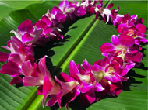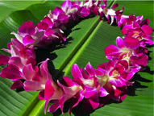

Sound
Comes with microphone(s) with stand, speakers, mixer/soundboard & direct input units.

Fee for Amplified Music/Sound System (Medium Sized)
(Usually recommended for guest counts over 50 ppl. or if your event is outside)
- ____– flat fee for the entire duration of our performance
- ____/additional hour (if youʻd like to use microphone for your annoucements, toasts, etc.)

Our musicians will plug into your Sound System & use your microphones
- Free of Charge

Play acoustic (recommended for small, indoor events only)
- Free of Charge

For events with 100+ people
- Inquire

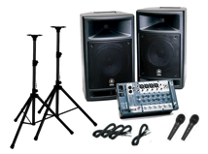

Deposits & Payments

We require a 50% non-refundable deposit to confirm your event date & entertainment. The remaining balance is due not later than 2 weeks prior to your event date.

Contact us
Hope this information helps! If you have any Qs or would like to book, please let us know the following information soon:

Date:
Start Time:
Location & Address:
# of ppl in attendance:
Indoor or Outdoor:
Type of Event (wedding, corporate, family celebration, etc.)
Your phone number:
Would you like purchase sound from us? Or will you provide sound? We also play acoustic free of charge, but this is only recommended for smaller &/or indoor events:
Event coordinators name, email & cell (if you have a coordinator):
A little bit about your Event- It's helpful for us to know a little bit about you so that we can tailor our performance for you. :)

Aloha!
Malia
Malia Haumschild, MBA
Owner, Hula Hula Entertainment
HulaHulaHawaii.com
808-264-1358
Joyful, Authentic, Hawaiian Entertainment
